Static:

* The **static keyword** in java is used for memory management mainly.
* We can use static for variables, methods, blocks.

Static variables:

* + If we created any variable with static we can directly access with class name we no need to create an object for the class.
* The static variable gets memory only once in the class area at the time of class loading.

Example:

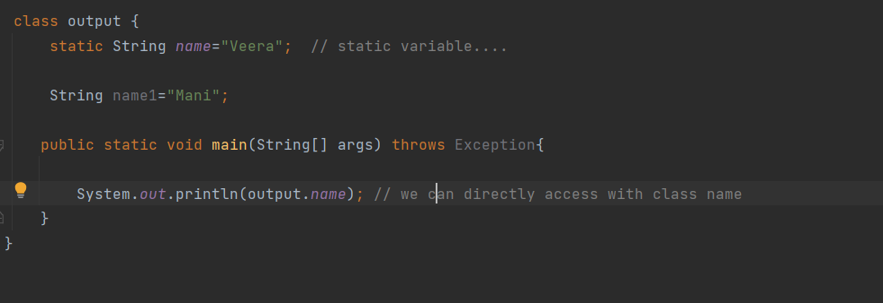

Output:

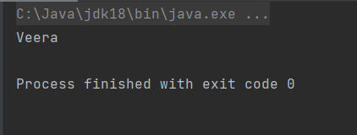

Static methods:

* + Static methods belongs to class rather than object of class.
  + Static methods invoked every time without creating instance of class.
  + Static methods can accept only static variables and static methods only.

Example:

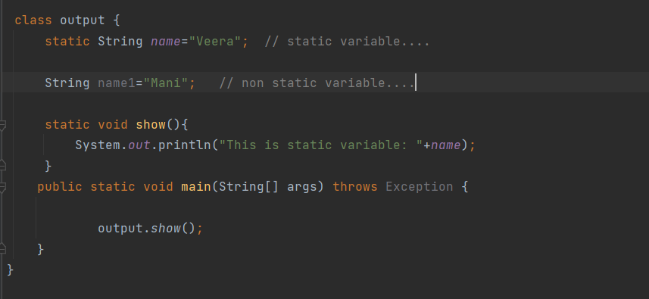

Output:

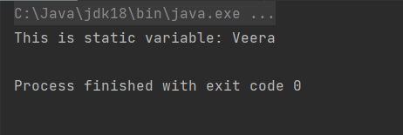

Static blocks:

* Is used to initialize the static data member.
* It is executed before the main method at the time of class loading.
* Static block is execute

Example:

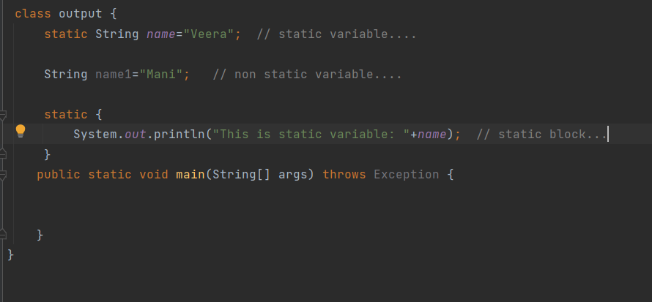

Output:

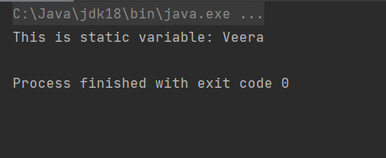

Final:

* The final keyword in java is used to restrict the use.
* We can use final for ,

1. Final variables.
2. Final methods.
3. Final classes.

* Once we create anything with final we cannot modify or we cannot change.

Final variables:

* Once we create a variable with final keyword we cannot modify that variable (it will be a constant).

Example:

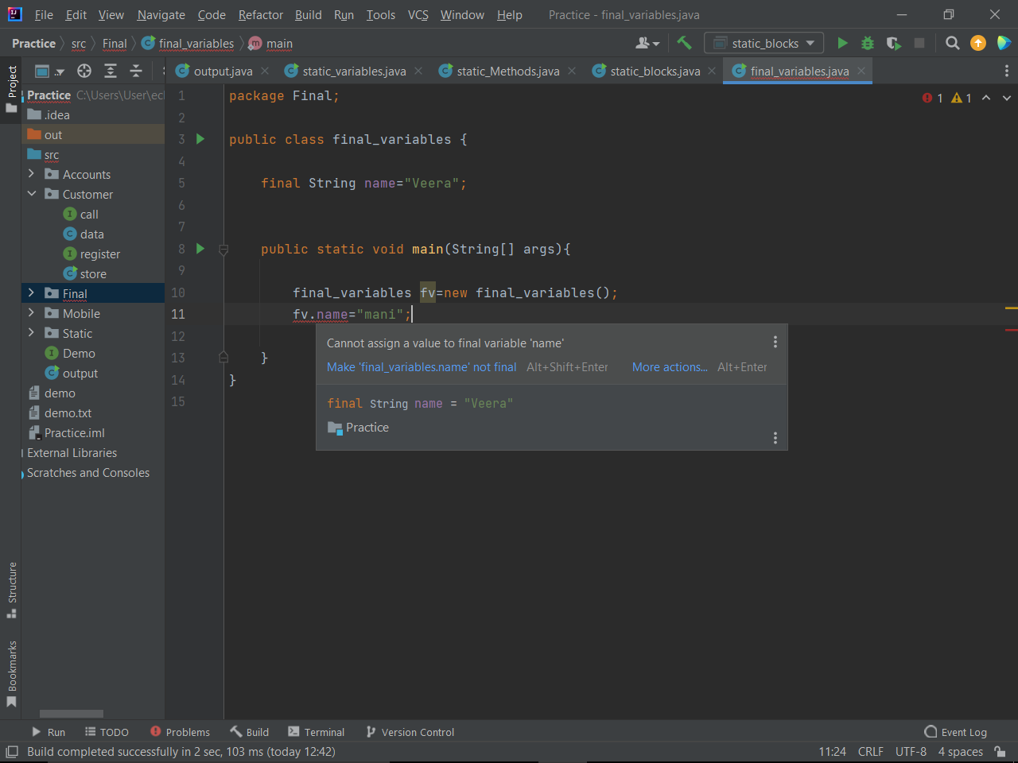

* See above example i created a name variable with final key word I try to change variable using object ref of class it showing we cannot assign a value to final variable.

Final method:

* If you make any method as final, you cannot override it.
* Method that declared with final key word is a final method.

Example:

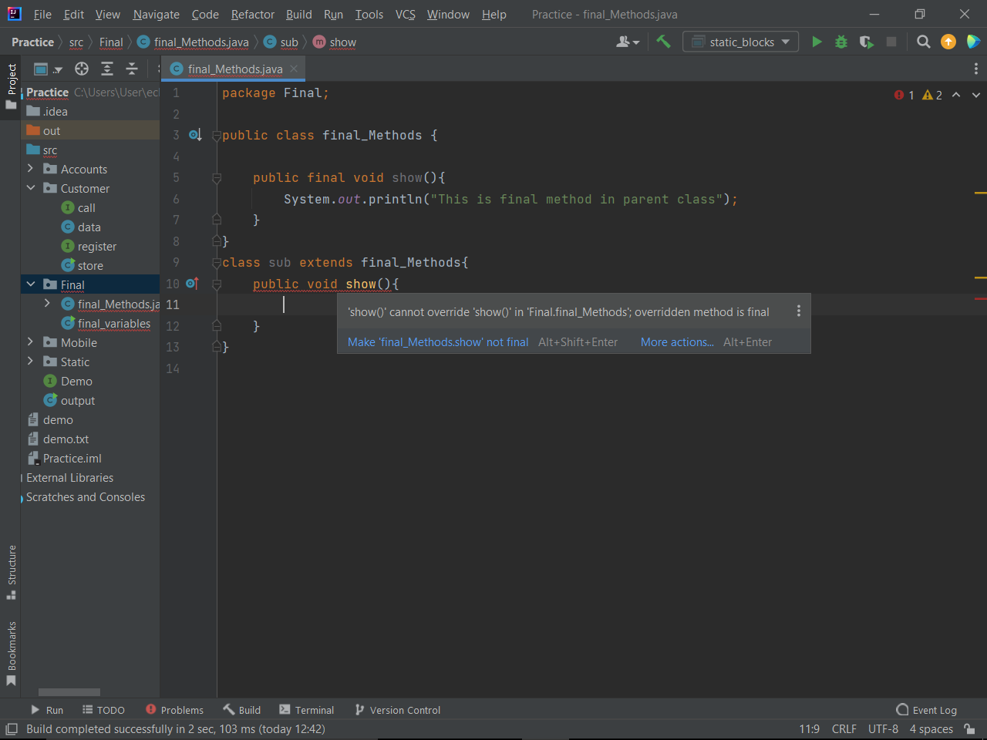

* In above example I am try to override the final method in child class (sub class) but it showing compile time error that we cannot override the final methods.

Final class:

* If you make class as final we cannot extend.
* The class that declared with final key word is a final class.

Example:

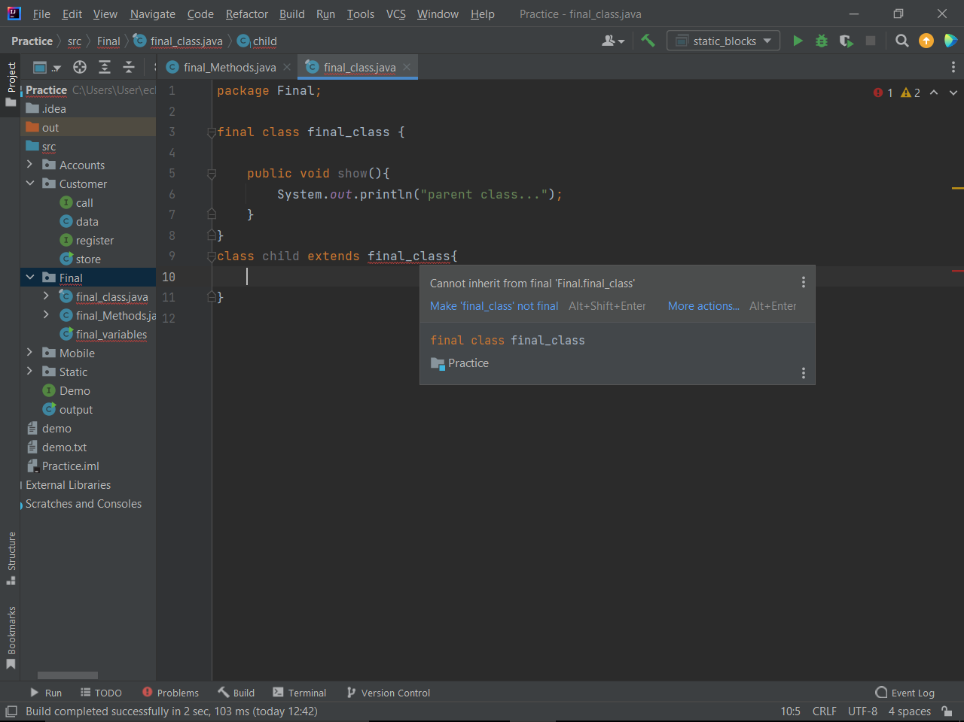

* See above example once we create a class with final we cannot extend that class.

Packages:

* Packages is a group of similar type of classes, interfaces and sub packages.
* Packages in java is divided into a two types

1. Build in packages.
2. User defined packages.

Example:

Build in packages.

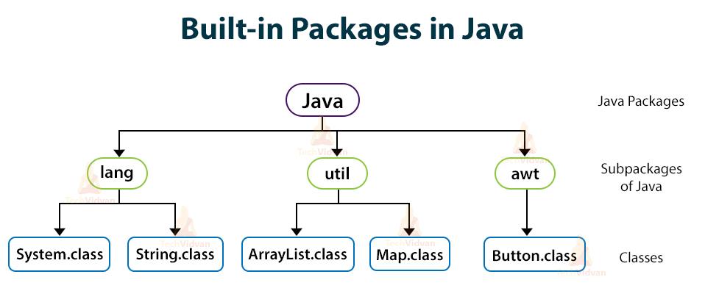

User defined packages:

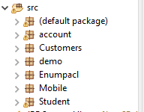

Access Modifiers:

* In java there are 4 type of access modifiers

1. Public access modifier.
2. Private access modifier.
3. Protected access modifier.
4. Default access modifier.

Public access modifier:

* Public access modifier is use for variables, methods and classes.
* One we declare any variable, methods or class with public we can access anywhere in the project.

Example:

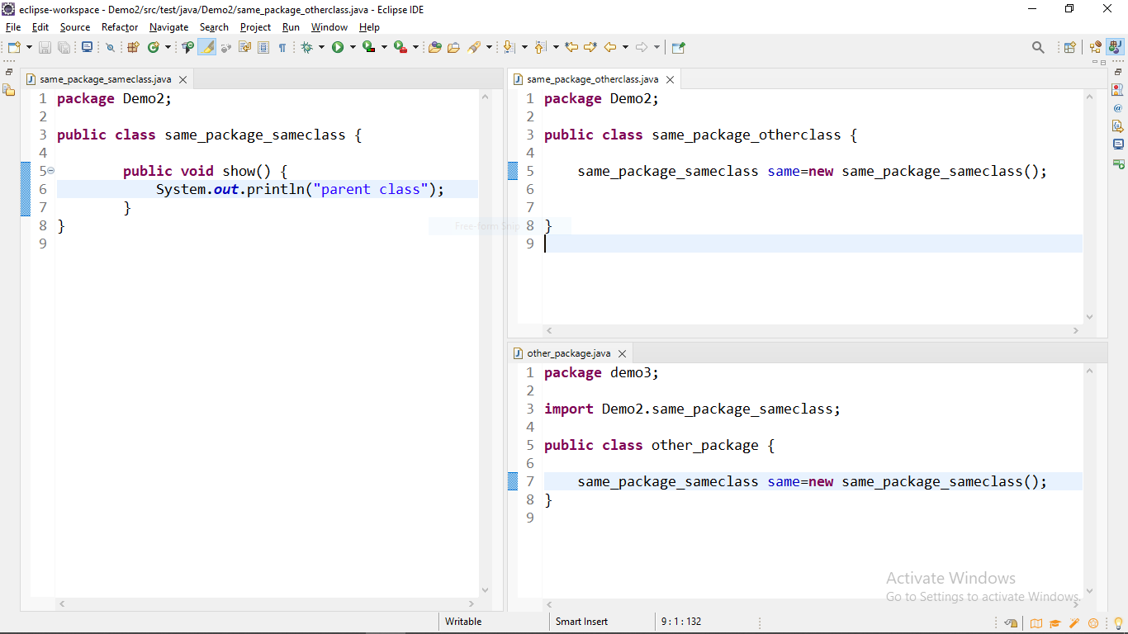

* See above example there are three classes there is a class with public we can access that class with in package and outside package also.

Protected:

* Private access modifier is use for variables and methods.
* One we declare any variable, methods with private we can access with in class only.

Example:

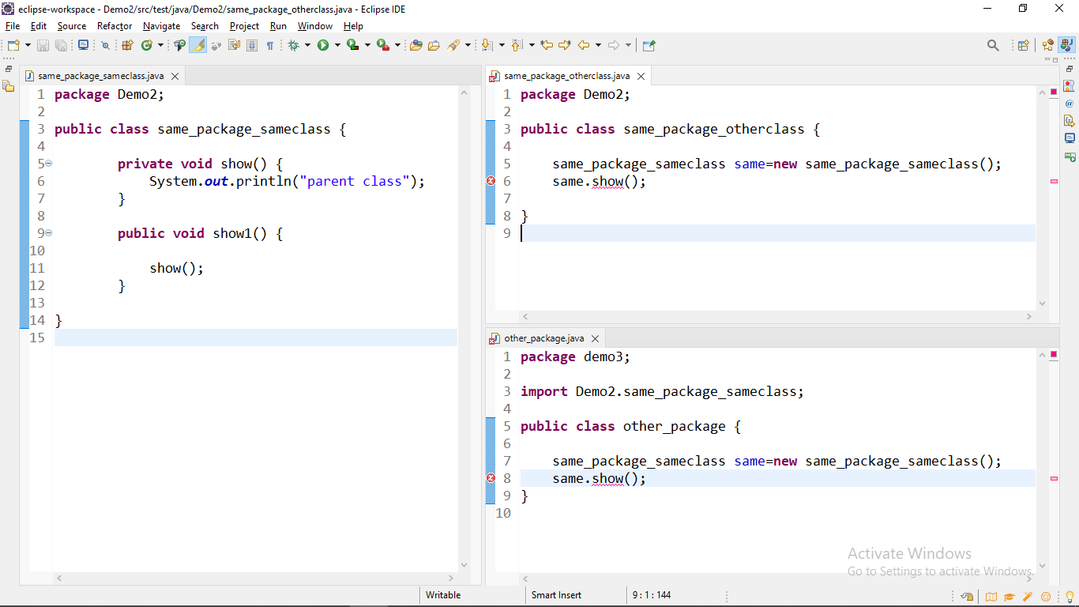

* Once we create variable or method with private we can access with in same class only.

Protected: